**Session 10**

**B-Tree**

**B-Tree Property**

Tree is a non-linear data structure that represents hierarchical. It is a collection of one or more nodes linked by pointers.

b-Tree = self balancing tree data structure that maintains sorted data and allows operations in logarithmic time.

The B-tree generalizes the binary search tree, allowing for nodes with more that two children.

Setiap children bisa lebih dari 2 children dan setiap node bisa lebih dari 1 key.

M = batas maksimal sebuah node punya brapa children.

1. Every node has at most m (order) children.
2. Internal node (except root) has at least [m/2] child nodes.
3. Root has at least 2 children if it is not a leaf node.
4. Internal node with k children has k-1 keys.
5. All leaves appear in the same level.
6. Every node (except root) has at least [m/2] – 1 keys.

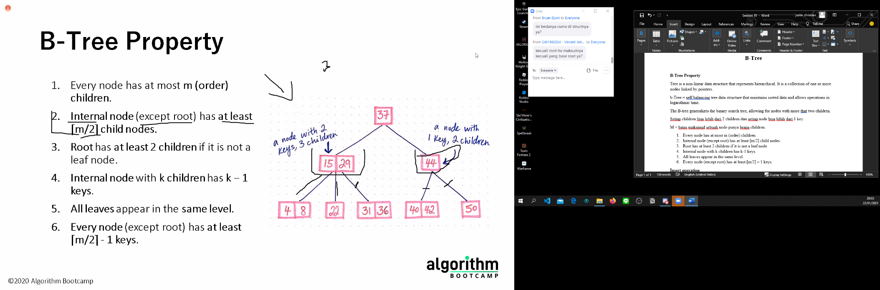

I am losing brain cells hearing his explanation

**Insert operation**

**Search Operation**

**Delete Operation**